
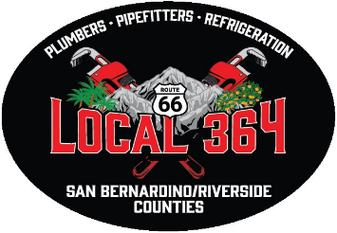
NEWSLETTER - January 2026

UA Local 364
223 S. Rancho Ave., Colton, CA 92324 • (909) 825-0359 • Fax: (909) 824-8362
Website: www.ualocal364.com
Office Hours: Monday – Friday 7:30 am - 4:30 pm • Closed from: 12:00 pm - 1:00 pm

Follow us on Facebook! Search for UA Local 364 from your Facebook page.

LOCAL 364 UNION MEETINGS
Local 364 Union Meetings are held on the third Thursday of each month at 6:00 pm unless canceled or *rescheduled. The hall doors will open at 5:00 pm. Dinner will be served. Upcoming meeting dates:

January 15, 2026 | 6:00 pm
February 19, 2026 | 6:00 pm
March 26, 2026* | 6:00 pm
April 23, 2026* | 6:00 pm
May 21, 2026 | 6:00 pm
June 18, 2026 | 6:00 pm
July 16, 2026 | 6:00 pm
August 13, 2026* | 6:00 pm
September 17, 2026 | 6:00 pm
October 15, 2026 | 6:00 pm
November 19, 2026 | 6:00 pm
December 17, 2026 | CANCELLED



Welcome to 2026! We hope you had a wonderful holiday season filled with joy and unforgettable memories. As we enter this new year, we are excited about the opportunities and new adventures that lie ahead. Let’s make this year the best one yet.

MEMBERSHIP CARDS
Enclosed is your 2026-2028 membership card.
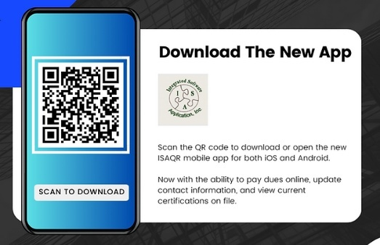

LOCAL 364 MEMBER PICNIC

The Member Picnic will be on Saturday, April 25, 2026, from 11:00 am – 4:00 pm. The picnic will be held at the Yucaipa Regional Park. The park entrance fee will be $10 per vehicle. The food will be catered by In-N-Out Burgers. There will be raffle prizes, music, and fun for all. Every member will receive 10 free raffle tickets during check-in. Additional tickets can be purchased for $1.00 each. At the end of the picnic there will be a 50/50 drawing. The picnic is for Local 364 members and their immediate family. Don’t forget to bring your park chairs.

APPRENTICESHIP GRADUATION


Please join us in celebrating the success of the 2025 Apprenticeship Graduation Class. The apprentices who completed their apprenticeship between January 1, 2025 – December 31, 2025, will be honored at the Local 364 Member Picnic on Saturday, April 25, 2026. Family is welcome to attend the event.

RETIREE LUNCHEON

Retirees, please join us for lunch and raffle prizes on Wednesday, April 08, 2026, from 12pm -2 pm. If you wish, bring a complimentary side dish or dessert. Spouses are welcome!


CSPTC SCHOLARSHIP

The California State Pipe Trades Council Scholarship Foundation awards college scholarships to U.A. Local Union Members in good standing for at least a full year. Forty scholarships in the amount of $2,500 will be awarded to the winning applicants. Applications and the required accompanying materials will be accepted beginning November 1, 2025. They must be postmarked no later than March 1, 2026. Applications must be received within five business days after the deadline.
Only COMPLETE applications will be eligible. You can find the instructions and download the rules and application on the California State Pipe Trades Council website at http://calpipes.org/.

APPRENTICE ONLINE OJT HOURS
Apprentice on-the-job hours are due the first week of January 2026. Please submit your hours on the ISAQR application. Login with your QR code (10-digit number-last four of social ex: 111111111-9999) which can be found on the back of your membership card and your pin is your last name plus last four of social. Failure to submit your online OJT hours by the first week of January will result in summons to the JAC, and you will not be upgraded.

JOURNEYMEN UPGRADE TRAINING
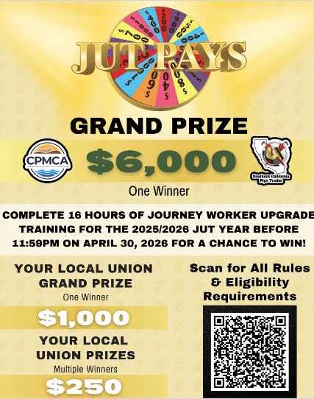
Complete JUT 2025/2026 hours before 11:59 pm on April 30, 2026, for a chance to win! The JUT Pays Drawing is subject to all rules and eligibility requirements. Scan QR code below.

APPRENTICE COMPETITION
Local 364 is hosting a Local Apprentice Competition on Saturday, February 21, 2026, at the Colton Training Center. For more information view the flyer below.


A&J TRAINING TRUST FUND
Spring 2026 apprentice schedules are now available! It is your responsibility to know your schedule, inform your employer of training dates and check for scheduling updates regularly. Download the ISAQR App to access your A&J member profile from your Apple or Android device. If you already have the ISAQR App on your phone, simply log in to view your class schedule. To login, please follow the instructions listed below.

- Open the ISAQR APP on your phone & login with your A&J Training Trust username & password.

USERNAME:
- Your 7-digit UA Card # + AJ (MUST BE IN CAPS).
- Example: If your UA Card # is 1234567, then 1234567AJ is your username.
PASSWORD:
- The last four digits of your social security number.

NOTE: Your A&J Training Trust username and password is different from your local union login credentials.

- Tap the Hamburger Menu and select Grades from the menu.

- PRO-TIP: If the menu items outlined above do not match, use the hamburger menu to log out and sign back in with your A&J credentials. This may occur if you are logged in under your Local Union credentials.

- View your upcoming classes.

- All classes & corresponding training center information appears here.
- Tap the course name for class dates, instructor, location (room number) and times.

JOB OUTLOOK


The 2026 Job Outlook looks promising as there are several nice sized projects slated to start this year.
Kaiser Riverside Tower - A.O Reed and Pan Pacific – job is winding down and coming to an end.
29 Palms Barrack s- SSW and Xcel Mechanical - SSW is wrapping up and Xcel Mechanical is holding with current manpower on site till end of the project.
View Behavioral Health - Colton, ACCO - job is manned up, holding 6 Plumbers.
Palm Springs Library - ACCO - was awarded the Fitting and Southwest Plumbing was awarded the Plumbing and has begun hiring and will hire first quarter 2026.
College of the Desert – ACCO - will hire 6 Journeymen Pipefitters, 6 Apprentices and 4 Welders in the first quarter of 2026. Scheduled for completion mid-2027.
Oasis Park UCR – ACCO - expects to hire first quarter 2026.
Pacific Village Campus Project Highland – ACCO - slowed down due to footing issues. Currently back on site, project should gain some momentum and hire more Plumbers and Fitters first quarter of 2026.
Adelanto Converter Station- Control Air - is currently manned up and will hire more in the first quarter of 2026.
Ft. Irwin - Control Air – finishing up current phase and will hire again May 2026.
*ACCO continues to pick up work all over our jurisdiction.
* SSW is still biding a lot of work in the low desert and Ft. Irwin.
There is still a lot of work across the country if anyone is interested in travel opportunities. Reach out to your Business Agents
DEPARTED MEMBERS


Christopher Penny..…..…………..……...….. 10/15/2025
Matthew Titus……..…..…..……………….…...10/23/2025

On behalf of UA Local 364 Staff and Officers, we would like to extend our deepest sympathy to the families of our departed members.

2026 ELECTIONS
The first quarter of 2026 will be busy with several elections. We will be nominating and electing new Officers for Local 364, Delegates for the 104th CA State Pipe Trades Convention, and Delegates to the 41st UA General Convention. The timeline breakdown for each is as follows.

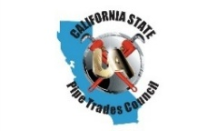
CALIFORNIA STATE PIPE TRADES CONVENTION

Nominations for the 104th CA State Pipe Trades Convention will be held at the Hall on Thursday, January 15, 2026, 5:00 PM – 5:30 PM. Journeyman must be in good standing for two years to run. Journeymen, 4th & 5th year Apprentices in good standing for one year may vote. A candidate must be present to accept the nomination or have a signed letter of acceptance presented at the time of nomination by the nominator. A Candidate meeting will be held immediately following nominations.
Parking lot election to be held Saturday, February 21, 2026, from 11 AM to 2 PM at Local 364.
The convention will be held in San Francisco, CA on May 13-15, 2026.
*In the event of a tie, a coin toss will determine the tie breaker

41st UA GENERAL CONVENTION

Nominations for the 41st UA General Convention will be held at the hall on Thursday February 19, 2026, from 5:00 PM to 5:30 PM.
Journeymen, 4th & 5th year Apprentices in good standing for one year may vote. Journeyman must be in good standing for two years to run.
Parking lot election to be held Saturday, March 28, 2026, from 11 AM to 2 PM at Local 364.
The convention will be held in San Diego, CA on August 17-21, 2026.
*In the event of a tie, a coin toss will determine the tie breaker.

ELECTION OF OFFICERS FOR UA LOCAL 364

Local 364 is scheduled to have an Election of Officers in June 2026. Per the General Executive Board’s decision to exercise its authority under section 122(e) of the United Association Constitution requiring locals to advance their elections. Local 364 will be advancing our Election of Officers.

The Election Committee consists of: Chair Richard Edwards, Bill Garner, Marcel Fortin and Michael Teal. The committee will be using Local Union Reports to determine nomination eligibility and overseeing the election process.
Offices to be filled: President, Vice-President, Business Manager, Financial Secretary- Treasurer, Recording Secretary, Inside Guard, Executive Board (Elect-4), Examining Board (Elect-3), Finance Committee (Elect-3), Delegate to District Council 16 (Elect-2).

- U.A Local 364’s Election Committee will conduct an in-person nominations meeting, at Local 364’s meeting hall, 223 South Rancho Ave, Colton, CA. Thursday January 15, 2026, 5:30 PM – 6:00 PM.
- Nominations in writing may be delivered in-person, email or by mail prior to the meeting of January 15, 2026. Nominations by email should be addressed to the Election Committee of Local 364 using the following address: Crystal@ualocal364.org. Nominations by mail should be addressed to the Election Committee at our regular street address, 223 South Rancho Ave, Colton, CA 92324. All nominations must be received no later than 5:00 PM on Thursday, January 15, 2026. Self-nominations are permitted and no “second” is required for self-nomination.
- The Election Committee Chair shall contact members who are nominated by other members, and are not present at the time of nomination (unless there is a letter of acceptance at time of nomination), regarding their decision to accept or not accept the nomination. This shall be done as expediently as possible.
- No member shall nominate more than one person for a specific office.
- If the nominated member is present, they shall accept or decline the nomination.
- Individuals nominating another member for office must be a 4th, 5th year Apprentice or Journeyman member in good standing.
- All nominated candidates must be a Journeyman member in good standing for two years. Eligibility of the nominated candidates is confirmed at the nominations meeting by the Election Committee on the spot. Local 364 will mail a list of all eligible candidates for all union offices to all eligible voters. A member may only be nominated for one office (Delegate to DC-16 is not considered an office of the Local and any otherwise eligible candidates may run in addition to a Local Office).

Eligible voters are Journeyman level members, as well as 4th or 5th year Apprentices, in good standing for one year, prior to vote count. Eligibility list for qualified candidates and for eligible voters will be available for inspection at the time of nominations.

Per Local 364 bylaws, voting shall be by mail ballot. There will NOT be in-person voting.

Ballots will be mailed on Monday February 2, 2026 (30 days prior to counting).

Ballots will be sent to a Post Office Box and picked up by 11:00 AM and tabulated on March 6, 2026.

*In the event of a tie, a coin toss will be used to determine a winner on March 6, 2026.

Newly elected officers will take office in July 2026.

